**Command lane argument :-**

**Modules:**

* **If you want any module its we have to important module once we can import the module then we can called any function of that module .**
* **We can creat alias name using as key word .**
* **Once we create alias name by using that we can access function and variable of that module .**
* **Import math as m in the syntax m is alias name for math module .**
* **Ex:-**
* **Form.1**

**import math as m  
print(m.sqrt(36))  
print(m.pi)  
print(m.ceil(22.89))  
print(m.floor(44.95))  
print(m.pow(2,4))  
print(m.factorial(5))  
print(m.sin(45))  
print(m.gcd(100,250))**

**output:-**

**6.0**

**3.141592653589793**

**23**

**44**

**16.0**

**120**

**0.8509035245341184**

**50**

**Form .2**

**Ex:-**

**form math import pi  
r=2  
print("area of circle :",p1*r**2)**

**output: area of circle :12.566.**

**form.3**

**ex:-**

**form math import sqrt**

**print(“area of circle :”,sqrt**

**output:-**

**area of circle :<buit in function sqrt>**

Command line argument **:-**

* **To supply the argument in a command prompt that why it is called command line arguments.argvis not a array’**
* **Argv in the form of list.**
* **Argv present in sys module .**
* **Argv [0]-represent name of the program .**
* **File name**
* **[Test.py.10.20.30]**
* **The default zero th argument is file name.**

**Ex:-**

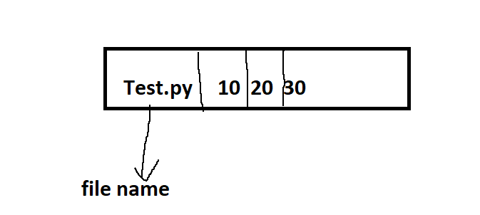

**Step1: type the program in IDLE.**

**Step2 : save the file.**

**Step3 : file->open->select the filename->copy the path.**

**Step4:startbutton +R->CMD->ok.**

**Cd (space)->paste the and press enter.**

**Ex :**

**Py Test.py 10 20 30 and press enter.**

**Output:**

**[‘test.py’,’10’,’20’,’30’]**

**4**

**Arguments: test.py**

**Arguments: 10**

**Arguments: 20**

**Arguments: 30**